Google Hacking Technique

Task 1 – Find PDF files about IPL cricket rules
Where to do it: Google Chrome → Google Search.
Search query to copy and paste:
IPL cricket rules filetype:pdf
You can narrow the search to the official IPL website with: site:documents.iplt20.com filetype:pdf playing conditions
Three official/public cricket-rule PDF links to start with (open them and confirm they load):
- TATA IPL Match Playing Conditions PDF: https://documents.iplt20.com/bcci/documents/1744793798426_1742708035368_Match_Playing_Conditions.pdf
- BCCI Men’s T20 Playing Conditions 2025–26 PDF: https://documents.bcci.tv/smart-images/1772193553050_2025-26_BCCI_Men_T20_PC.pdf
- BCCI Playing Conditions page: https://www.bcci.tv/news/article/playing-conditions
- 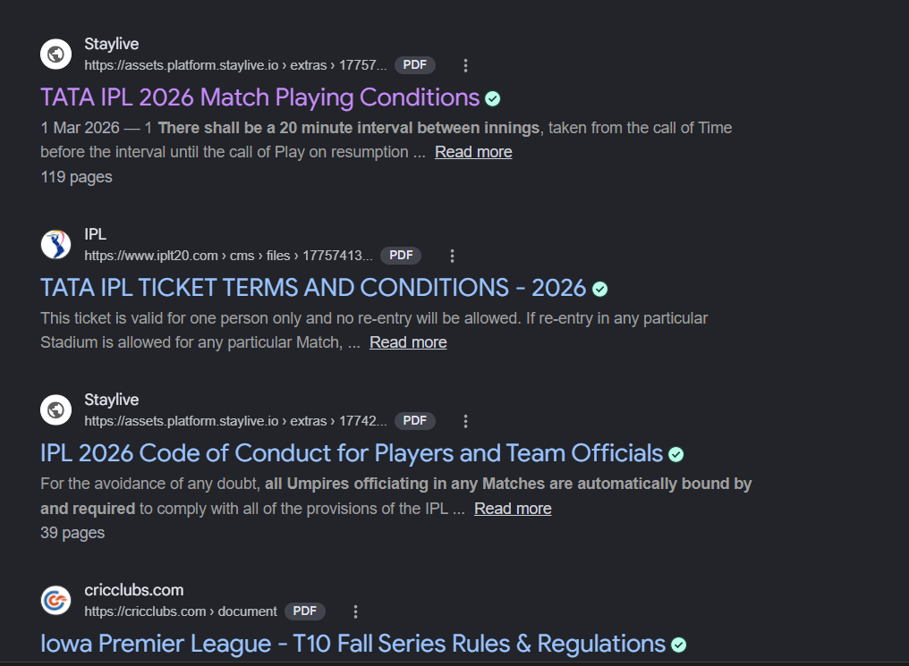

Task 2 – Search for Zomato login pages
Where to do it: Google Search.
Search query:
inurl:login site:zomato.com
Why it works: “site:zomato.com” asks Google to show results from the zomato.com domain. “inurl:login” asks Google to show pages whose web address contains the word “login”. The two operators work together to narrow the search.
Steps: (1) Open Google. (2) Paste the query. (3) Press Enter. (4) Record the query and the number/type of relevant results you see. (5) If a result appears, describe it as a search result only; do not attempt to access restricted areas or test credentials. If there are no results, write “No matching result was displayed at the time of my search.”
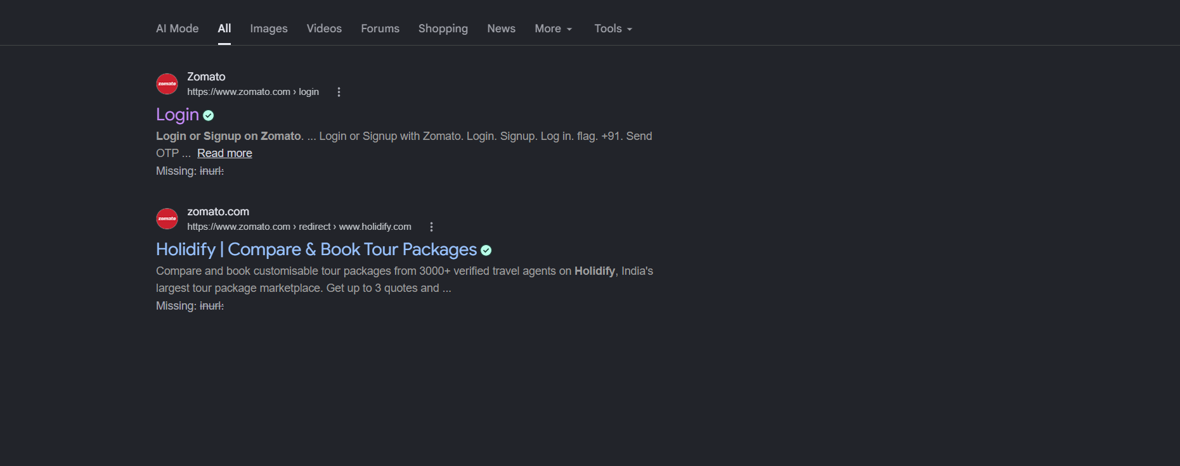

Task 3 – Search for public Excel files containing “playlist” on Spotify-related domains
site:spotify.com playlist filetype:xls OR filetype:xlsx
Alternative query: site:newsroom.spotify.com playlist filetype:pdf OR filetype:xlsx
Steps: (1) Search using the first query. (2) Look only for an openly published, non-sensitive spreadsheet that is clearly intended for public use. (3) If you find one, copy its title and URL into your assignment. (4) Do not download or share files containing personal information, internal business data, access tokens, or confidential information. (5) If no suitable public Excel result appears, record that honestly and try the alternative query or ask your instructor whether a public Spotify-related partner page is acceptable.
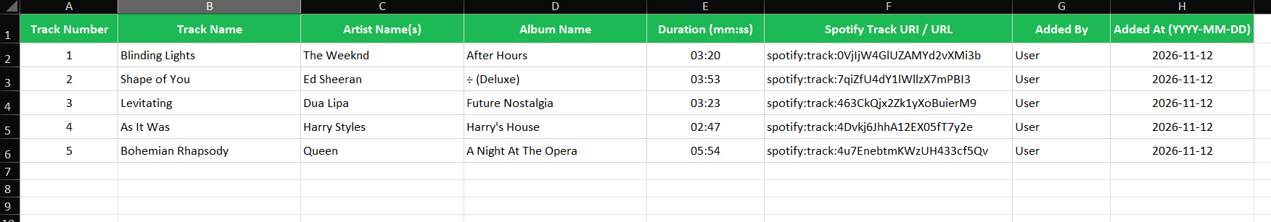

Task 4 – Understand the risk of exposed admin panels
Where to do it: Google Search for the search-operator demonstration only.
Example query from the assignment:
intitle:admin site:flipkart.com
How it works: “intitle:admin” asks Google to find pages with the word “admin” in the page title. “site:flipkart.com” limits results to pages indexed under that domain.
Safety: Do not open, sign in to, probe, scan, or test any real admin page you find. A search result does not prove that a page is vulnerable or even currently active. For a safe classroom demonstration, you can use the query on a domain you own or an instructor-provided lab domain.
Why exposed admin panels are risky:
- An unauthorized person may try to access private customer or business information.
- An attacker may change products, prices, orders, or website content if access controls are weak.
- An attacker may create unauthorized accounts or misuse administrator privileges.
- The business may face financial loss, service disruption, and loss of customer trust.



